**EXPERIMENT – 9**

**SET OPERATORS,NESTED QUERIES, JOIN**

create table items_exp9_csa_35 (

itemid int primary key,

itemname varchar(50) not null,

category varchar(50),

price decimal(10, 2),

instock int check (instock >= 0)

);

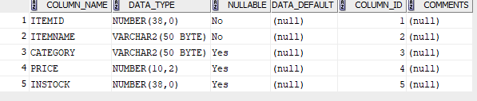

insert into items_exp9_csa_35 values (1, 'Samsung Galaxy S24', 'Electronics', 300.00, 50);

insert into items_exp9_csa_35 values (2, 'iPhone 15 Pro', 'Electronics', 800.00, 30);

insert into items_exp9_csa_35 values (3, 'MacBook Pro', 'Computers', 1400.00, 100);

insert into items_exp9_csa_35 values (4, 'Asus VivoBook', 'Computers', 980.00, 15);

insert into items_exp9_csa_35 values (5, 'Boat Headphone', 'Accessories', 6000.00, 60);

select * from items_exp9_csa_35;

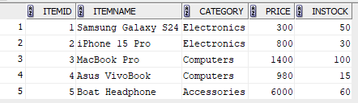

create table customers_exp9_csa_35 (

custid int primary key,

custname varchar(50) not null,

address varchar(100),

state varchar(50)

);

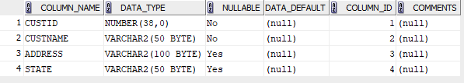

insert into customers_exp9_csa_35 values (1, 'Susan John', '303 Spruce Street', 'Illinois');

insert into customers_exp9_csa_35 values (2, 'George Paul', '404 Elm Street', 'Nevada');

insert into customers_exp9_csa_35 values (3, 'Hannah Mathew', '505 Willow Street', 'Ohio');

insert into customers_exp9_csa_35 values (4, 'Elvin Joe', '606 Chestnut Street', 'Michigan');

insert into customers_exp9_csa_35 values (5, 'Julia George', '707 Ash Street', 'Colorado');

insert into customers_exp9_csa_35 values (6, 'Mickey', '808 Pine Street', 'California');

select * from customers_exp9_csa_35;

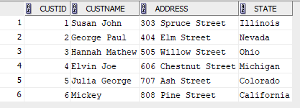

create table orders_exp9_csa_35 (

orderid int primary key,

itemid int,

custid int,

quantity int,

orderdate date,

foreign key (itemid) references items_exp9_csa_35 (itemid),

foreign key (custid) references customers_exp9_csa_35 (custid)

);

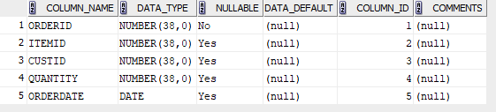

insert into orders_exp9_csa_35 values (1, 1, 1, 1, to_date('2023-02-01', 'yyyy-mm-dd'));

insert into orders_exp9_csa_35 values (2, 2, 2, 2, to_date('2023-03-15', 'yyyy-mm-dd'));

insert into orders_exp9_csa_35 values (3, 3, 3, 1, to_date('2023-04-20', 'yyyy-mm-dd'));

insert into orders_exp9_csa_35 values (4, 4, 4, 1, to_date('2023-05-10', 'yyyy-mm-dd'));

insert into orders_exp9_csa_35 values (5, 5, 1, 3, to_date('2023-06-01', 'yyyy-mm-dd'));

insert into orders_exp9_csa_35 values (6, 1, 6, 1, to_date('2023-07-01', 'yyyy-mm-dd'));

select * from orders_exp9_csa_35;

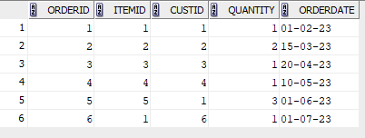

create table delivery_exp9_csa_35 (

deliveryid int primary key,

custid int,

orderid int,

foreign key (custid) references customers_exp9_csa_35 (custid),

foreign key (orderid) references orders_exp9_csa_35 (orderid)

);

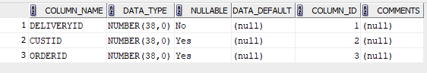

insert into delivery_exp9_csa_35 values (1, 1, 1);

insert into delivery_exp9_csa_35 values (2, 2, 2);

insert into delivery_exp9_csa_35 values (3, 3, 3);

insert into delivery_exp9_csa_35 values (4, 4, 4);

insert into delivery_exp9_csa_35 values (5, 1, 5);

insert into delivery_exp9_csa_35 values (6, 5, 5);

insert into delivery_exp9_csa_35 values (7, 6, 6);

select * from delivery_exp9_csa_35;

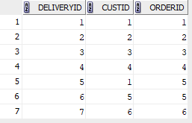

**QUESTIONS**

1. select c.*

from customers_exp9_csa_35 c

join orders_exp9_csa_35 o on c.custid = o.custid;

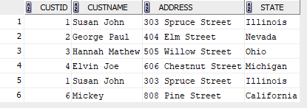

1. select c.*

from customers_exp9_csa_35 c

join delivery_exp9_csa_35 d on c.custid = d.custid;

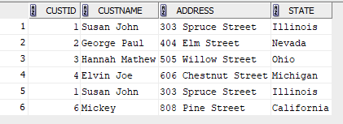

1. insert into customers_exp9_csa_35 values (7, 'Jackie', '808 Pine Street', 'California');

select * from customers_exp9_csa_35;

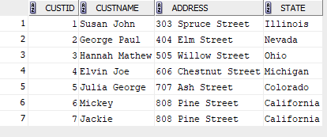

insert into orders_exp9_csa_35 values (7, 4, 7, 1, to_date('2023-07-01', 'yyyy-mm-dd'));

select * from orders_exp9_csa_35;

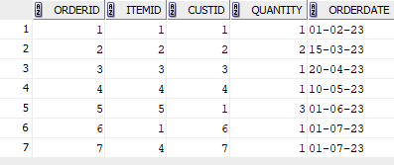

select o.orderdate

from orders_exp9_csa_35 o

inner join customers_exp9_csa_35 c on o.custid = c.custid

where c.custname like 'J%';



1. select i.itemname, i.price

from items_exp9_csa_35 i

inner join orders_exp9_csa_35 o on i.itemid = o.itemid

inner join customers_exp9_csa_35 c on o.custid = c.custid

where c.custname = 'Mickey';



1. select c.custid, c.custname, c.address, c.state

from customers_exp9_csa_35 c

join orders_exp9_csa_35 o on c.custid = o.custid

left join delivery_exp9_csa_35 d on o.orderid = d.orderid

where o.orderdate > to_date('2013-01-01', 'yyyy-mm-dd')

and d.deliveryid is null;



1. select distinct o.itemid

from orders_exp9_csa_35 o

union

select distinct o.itemid

from orders_exp9_csa_35 o

left join delivery_exp9_csa_35 d on o.orderid = d.orderid

where d.deliveryid is null;

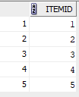

1. select c.custname

from customers_exp9_csa_35 c

join orders_exp9_csa_35 o on c.custid = o.custid

join delivery_exp9_csa_35 d on o.orderid = d.orderid;

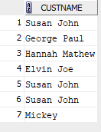

1. select custname from customers_exp9_csa_35 c

join orders_exp9_csa_35 o on c.custid = o.custid

minus select custname from customers_exp9_csa_35 c

join orders_exp9_csa_35 o on c.custid = o.custid

join delivery_exp9_csa_35 d on o.orderid = d.orderid;



1. select c.custname

from customers_exp9_csa_35 c

join orders_exp9_csa_35 o on c.custid = o.custid

group by c.custname

order by count(o.orderid) desc

fetch first 1 row only;



1. select distinct c.*

from customers_exp9_csa_35 c

join orders_exp9_csa_35 o on c.custid = o.custid

join items_exp9_csa_35 i on o.itemid = i.itemid

where i.price > 5000;



1. select distinct c.custname, c.address

from customers_exp9_csa_35 c

left join orders_exp9_csa_35 o on c.custid = o.custid

left join items_exp9_csa_35 i on o.itemid = i.itemid and i.itemname = 'Samsung Galaxy S24'

where i.itemid is null;

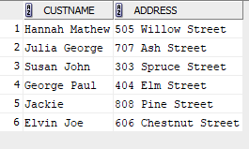

1. select distinct c.custid, c.custname, c.address, c.state, o.orderid, o.itemid, o.quantity, o.orderdate

from customers_exp9_csa_35 c

left join orders_exp9_csa_35 o on c.custid = o.custid;

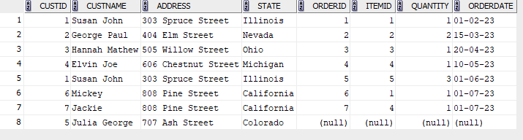

1. select c.custid, c.custname, c.address, c.state, o.orderid, o.itemid, o.quantity, o.orderdate

from customers_exp9_csa_35 c

right join orders_exp9_csa_35 o on c.custid = o.custid;

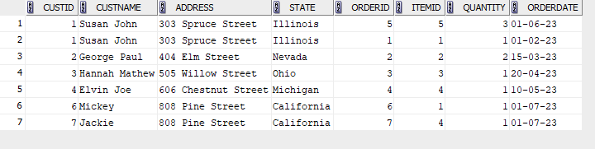

1. select c.state, count(*) as customer_count

from customers_exp9_csa_35 c

group by c.state;

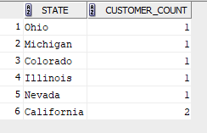

1. select category, itemname, price

from items_exp9_csa_35

where price > (select avg(price) from items_exp9_csa_35)

group by category, itemname, price;

